- I added a post but when I searched for it it did not display. I added screenjobs and searched for screens and nothing showed.
Input:
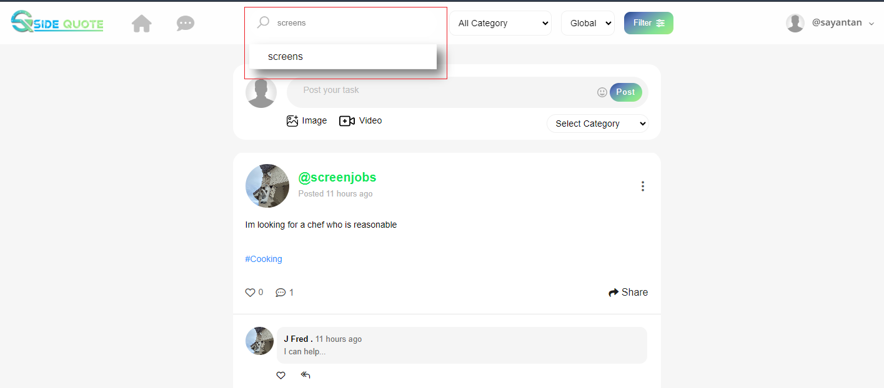
Output:
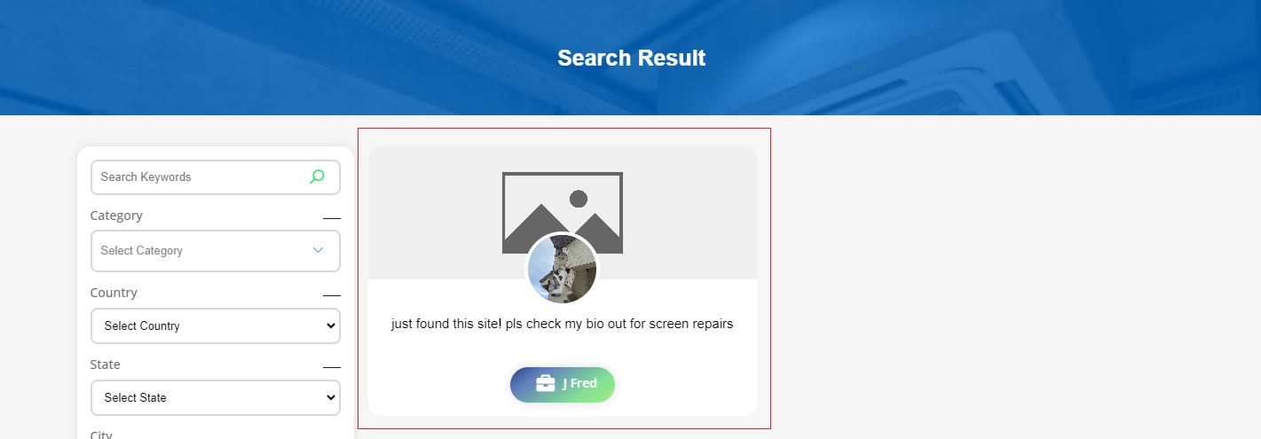

- The photo upload - are there specifications like file size limits because my other pics didn't upload in bio.
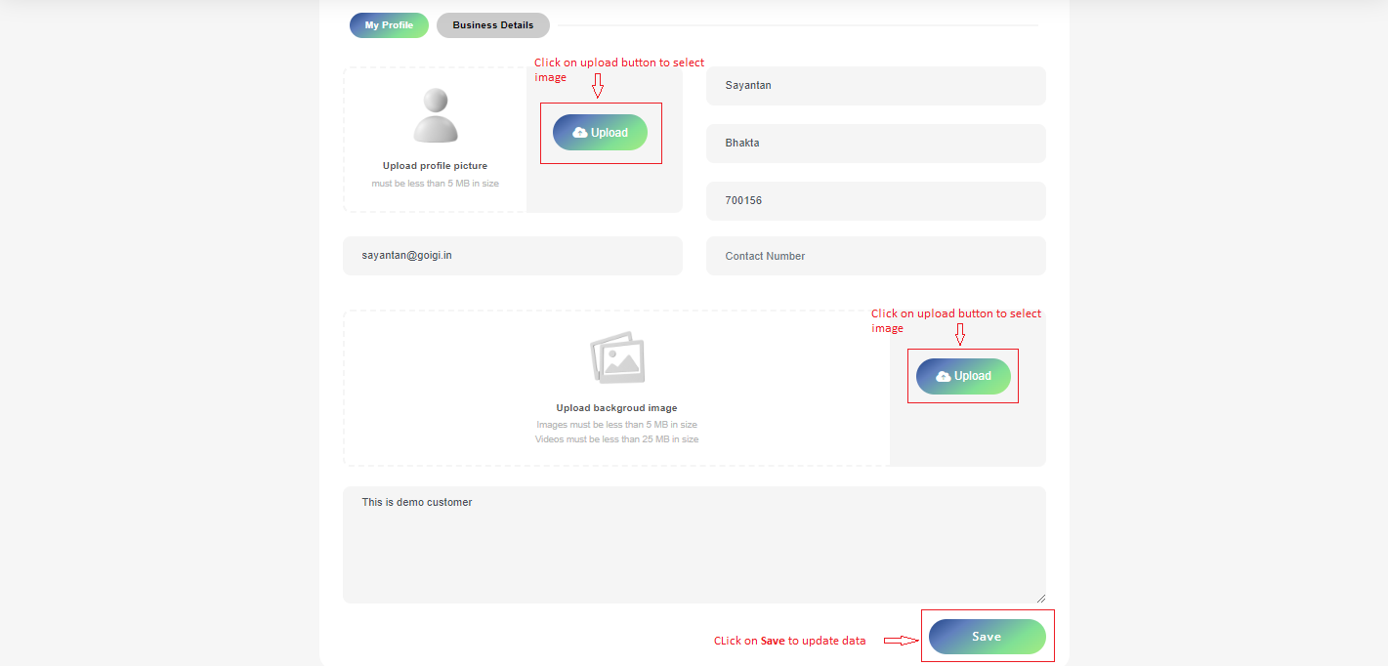
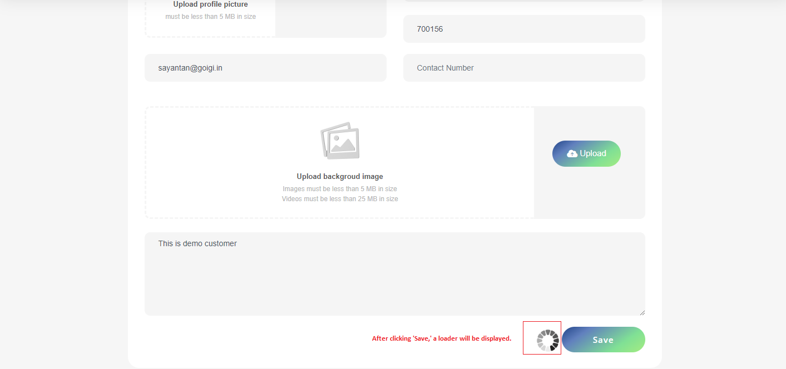

- Where is the ratings?
Profile Details page:
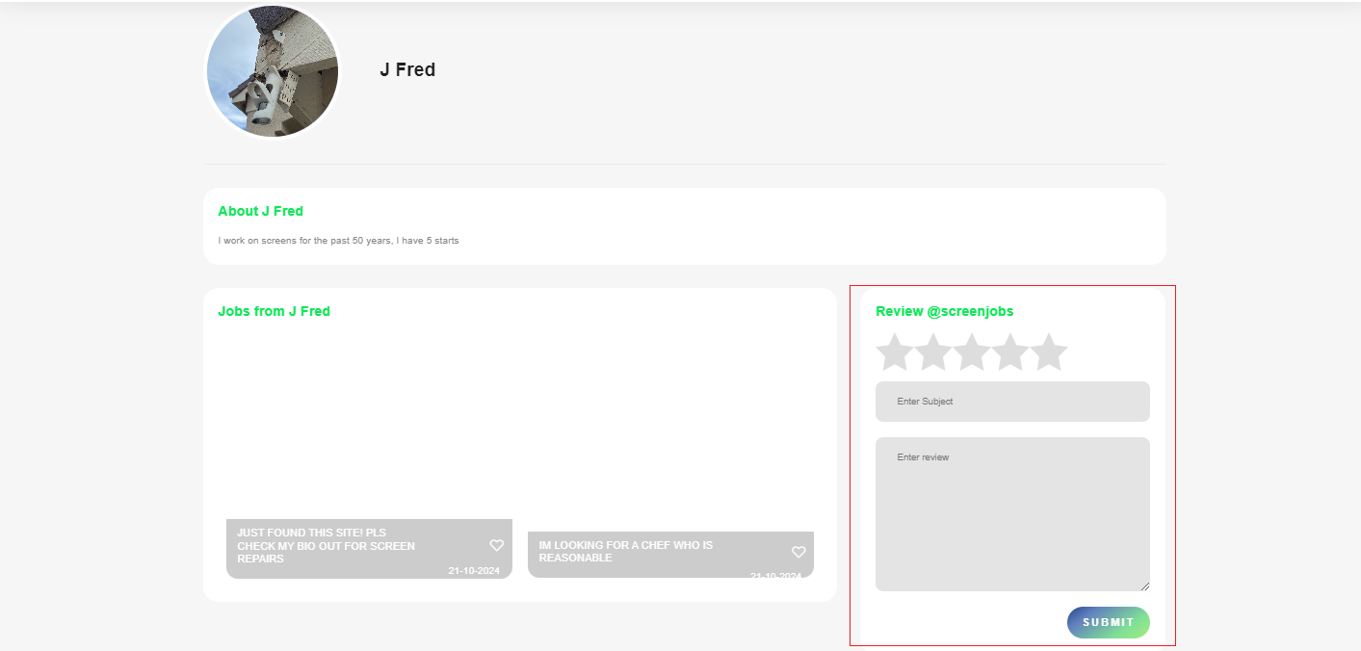
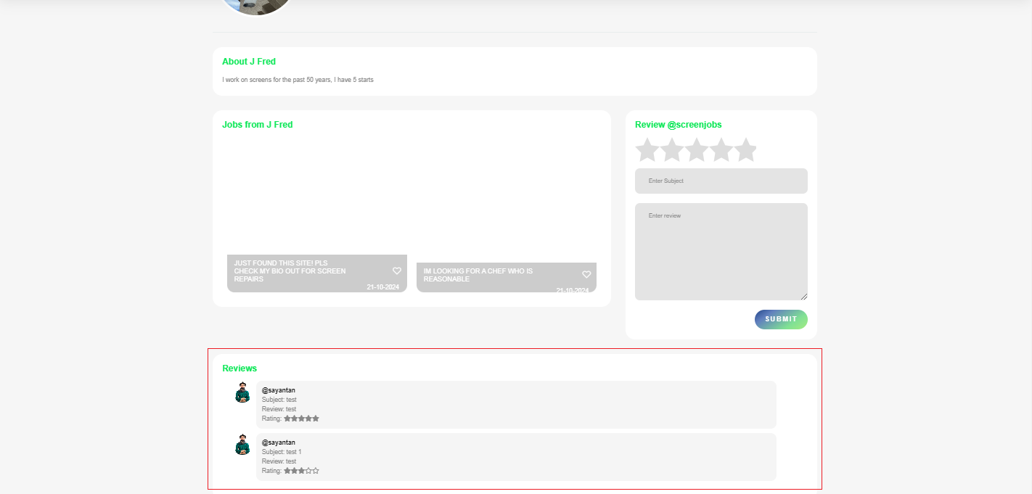

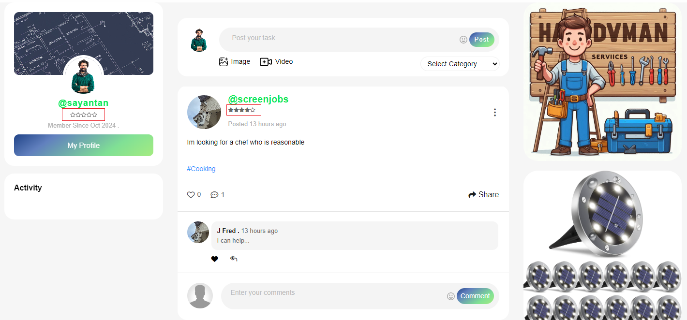

- In the admin panel I see Career Tips and Tool Tips but don't see where that maps to the Homepage.
